Design Document
Windows 95 Desktop Portfolio
Mohammed Sameer Sarfaraz Bake
sameer08055.github.io/personal-homepage

1. Project Description
This project is a personal portfolio homepage styled as a Windows 95 desktop. Instead of a conventional hero-and-sections layout, the homepage (index.html) renders a desktop with icons, a taskbar, a Start Menu, and a live clock. Double-clicking a desktop icon opens a draggable, closable “program window” (styled with the classic beveled gray borders and blue title bars) containing that section’s content — About, Projects, or Contact. Multiple windows can be open at once, each with its own entry in the taskbar, exactly like the real operating system.
The site is built entirely with vanilla HTML5, CSS3, and ES6+ JavaScript — no frameworks, no component libraries, no jQuery. All interactive behavior (window dragging, opening and closing, minimize and maximize, taskbar syncing, the Start Menu, and the live clock) is hand-written in ES6 modules.
To satisfy the requirement for multiple real HTML pages with distinct URLs — and to give visitors and graders a plain fallback — the same content also exists as ordinary standalone pages: about.html, projects.html, and contact.html. The Start Menu’s “Programs” list links directly to these, in addition to the desktop icons opening the content inline as windows.

2. User Personas
Three personas guided every design decision on this site:
 | Recruiter Rachel | Developer Dev | Client Priya
Age | 34 | 26 | 41
Role | Technical recruiter at a mid-size tech company | Front-end developer browsing portfolios for inspiration | Small business owner looking to hire a freelance developer
Goals | Quickly find a candidate’s skills, project examples, and contact info without needing to “figure out” a gimmick. | See an original idea executed well — functioning draggable windows and a taskbar built without any UI library. | Understand what kind of work this developer can do and how to reach them, without being confused by the retro interface.
Frustrations | Novelty homepages that hide real information behind too many clicks. | Portfolios that all look like the same template. | Interfaces that are “clever” but not usable.
Needs from site | A clearly labeled Resume icon, plus a plain about.html link as a fallback. | Working drag, focus, close, and a taskbar that actually reflects open windows. | An obvious way in, and a contact window that works like a normal contact page.

3. User Stories
- As Recruiter Rachel, I want to double-click a Resume/About icon on the desktop, so that I can see the developer’s background immediately.
- As Recruiter Rachel, I want a plain contact.html link available via the Start Menu, so that I have a normal fallback if I don’t want to interact with the desktop metaphor.
- As Developer Dev, I want to drag windows around the screen and have clicking a window bring it to the front, so that I can confirm the interaction is real and not decorative.
- As Developer Dev, I want each open window to show up as a button in the taskbar, and clicking that button to bring the window back into focus, so that the experience matches a real OS.
- As Client Priya, I want the Projects window to list real projects with short descriptions and links, so that I can see concrete examples of work.
- As Client Priya, I want a Contact window with an email link, so that I can start a conversation right away.
- As any visitor, I want a Start Menu with a “Shut Down…” option that shows a playful “It’s now safe to close this tab” screen, so that the site feels like it has personality without breaking usability.
- As any visitor, I want the clock in the taskbar to show the current time, so that the desktop feels alive rather than static.

4. Design Mockups

Desktop (index.html)
The homepage renders as a full desktop: labeled icons across the top, a live window in the middle (draggable, with working minimize / maximize / close controls), and a taskbar along the bottom with a Start button, one entry per open window, and a live clock.
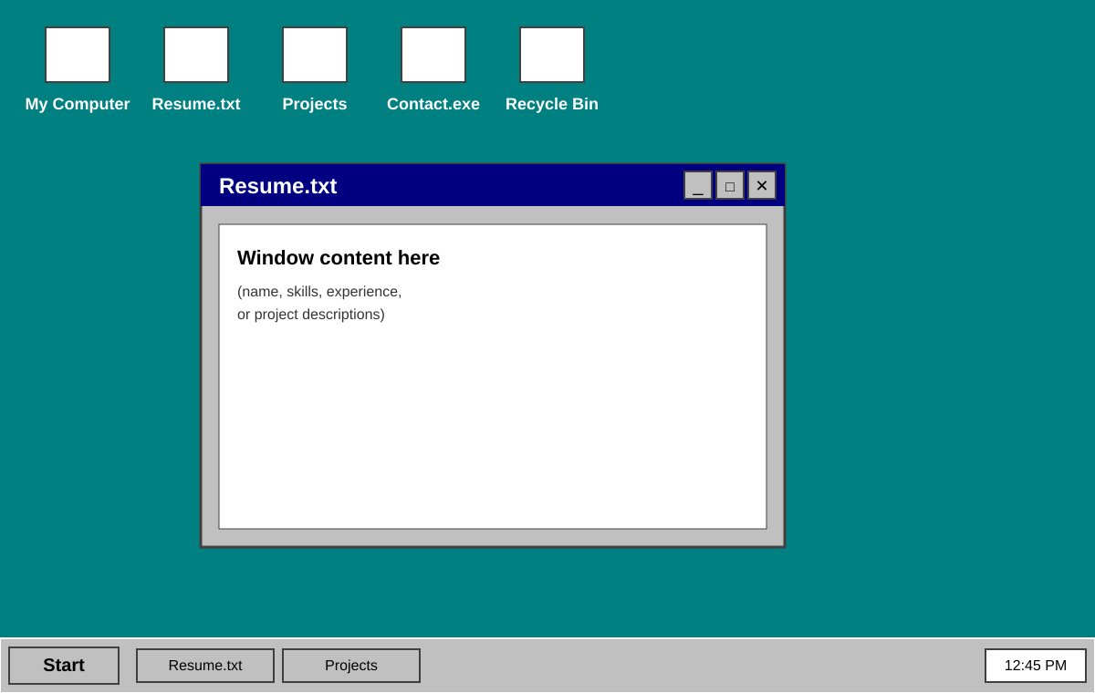

Plain fallback pages (about.html / projects.html / contact.html)
Each also exists as an ordinary, standalone page using a conventional header, content area, and footer — fully navigable without interacting with the desktop metaphor at all, and reachable via real, distinct URLs.
